PHYSIOTHERAPY PATIENT INFORMATION SHEET
PLEASE COMPLETE FULLY AND ACCURATELY
Name: __________________________________________ Date of birth: ____________________________ Age: __________
Address: ______________________________________City:___________________________ Postal code: __ __ __ - __ __ __

Home Phone: __________________________________ Cell Phone: _________________________________
Occupation: __________________________________ Marital status: _________________ AHC #: ______________________
Emergency contact (Name, Tel. # & Relationship): __________________________________________________________________
E-Mail address (for appointment reminders): ____________________________________________________________________
How were you referred to this clinic?__________________________________________________________________________

Are your injuries related to a Motor Vehicle Accident?  N  Y If yes, date of accident: ____________________________
FEMALES: Are you pregnant?  N  Y If yes, how many weeks? ___________________________
Please note that Megan Ewanowich does not accept WCB (Worker’s Compensation Board) Cases

CURRENT HEALTH HISTORY
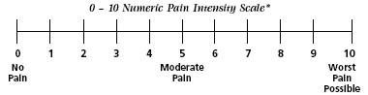
Current complaint(s) – in order of importance to you: On the drawings below, circle all painful areas:

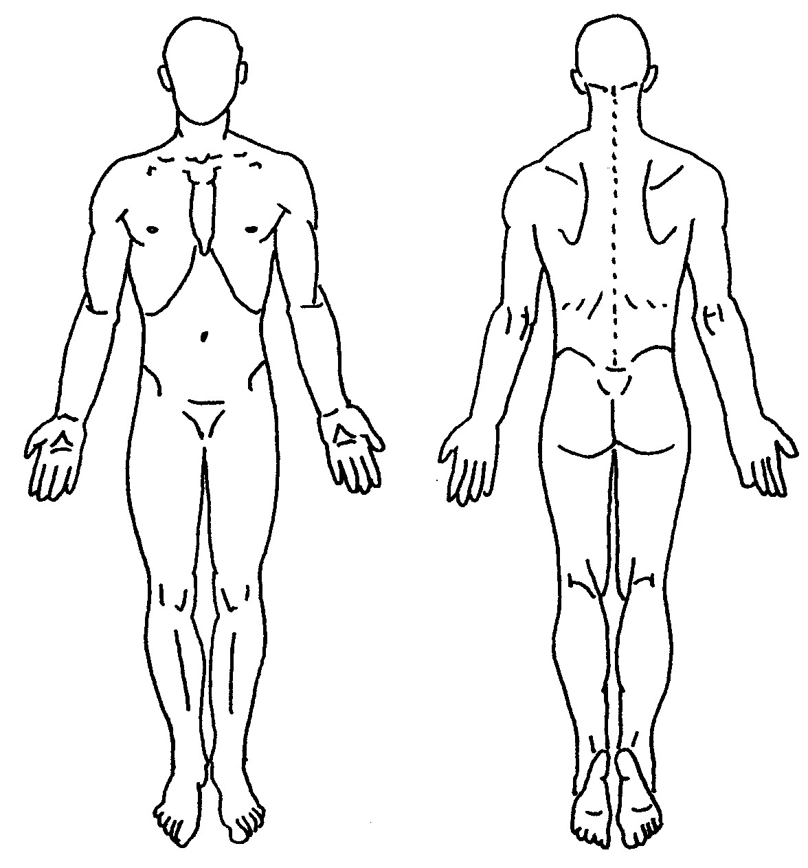
1) ___________________________________________________
2) ___________________________________________________
3) ___________________________________________________
Describe the pain:
 Sharp & stabbing  Burning
 Pins & needles  Dull, ache
 Numb  Stiff & tight
Circle your level of Pain/discomfort

List any medications, supplements (vitamins, etc.) that you are currently taking:
____________________________ | ____________________________ | ____________________________
____________________________ | ____________________________ | ____________________________
____________________________ | ____________________________ | ____________________________
____________________________ | ____________________________ | ____________________________

FAMILY HEALTH HISTORY
Have you or anyone in your family had the following (specify whom):
 Heart disease ____________________________________ High blood pressure ____________________________________
 Cancer _________________________________________  Diabetes _____________________________________________
 Stroke _________________________________________  Other: _______________________________________________

PAST HEALTH HISTORY
List any previous Surgeries and the year(s) they occurred:
1.____________________________________ Year ____________ 3.____________________________________ Year ___________
2.____________________________________ Year ____________ 4.____________________________________ Year ___________
List any previous Fractures/Breaks and the year(s) they occurred:
1.____________________________________ Year ____________ 3.____________________________________ Year ___________
2.____________________________________ Year ____________ 4.____________________________________ Year ___________

GENERAL HEALTH INFORMATION
Please check symptoms you have experienced in the past or currently:
 Seizures/Stroke  Bleeding Problems  Chest Pain/Angina |  Difficulty Speaking/Swallowing
 Osteoporosis  Anemia  High Blood Pressure |  Recent Fall (last 6 months)
 Osteoarthritis  HIV/AIDS/Hepatitis  Dizziness/Fainting Spells |  Pacemaker/ICD
 Rheumatoid Arthritis  Respiratory Condition  Hearing Loss/Change |  Nausea/Vomiting
 Headaches  Chronic Pain  Memory Loss/Change |  Changes in Bladder Function
 Tobacco/Cannabis use  Depression  Vision Loss/Change |  Changes in Bowel Function
 Poor Balance  Numb/Tingling  Fever/Chills/Sweats |  Unexplained Weight Loss
 Increased Pain at night  Recent Hospitalization  Skin Condition/Open Wounds  Metal Implants/IUD

FEES
Type of appointment | Fee
Initial visit | $115.00
Subsequent Visit | $75.00

Do you have extended health benefits?  YES  NO Benefits Provider: _________________________________________

Please check at the front desk if your Insurance Provider is eligible for direct billing. For direct billing, claims are submitted under PHYSIOTHERAPY. We are submitting the claim on your behalf and your Insurance Provider predetermines approval. If your claim is rejected, not covered or processed as pending, you are responsible for payment on your service at the time it is rendered.

If you cannot attend an appointment, or no longer need it, please give 2 HOURS NOTICE so that another patient may receive care during that time. Please be courteous to other patients who are in need of an appointment. Failure to do so will result in a $40.00 fee. Understand that when you book an appointment, that time is set aside specifically for you and reserved. We are often booked back to back so arriving late (10-15 minute maximum), will be cut into your appointment time, and we will only be able to give you the remaining time in your session. In these cases, the full session fee will apply. (More than 15 minutes will be considered a missed appointment and will have to be rescheduled.)

I have read the above and understand that I am responsible for all charges relating to my visit. The statements made on this form are accurate, to the best of my recollection, and I agree to allow this office to examine me for further evaluation.

Signature: __________________________________________________ Date: _______________________________

Staff Signature: ______________________________________________ Date: _______________________________

CONSENT FOR TREATMENT
- I understand that the health information collected is confidential in nature and will not be released without my prior written consent.
- I hereby consent to and authorize Megan Ewanowich, Licensed Physical Therapist, to perform therapeutic assessment and treatment.
- I understand that I can ask questions at any time, to clarify information and instructions provided by the therapist.
- I understand that I can withdraw my consent for participation at any time.
- I understand that the nature, purpose, and probable risks & benefits of all proposed treatments will be reviewed with me, including:

Acupuncture Therapy | Exercise Therapy
Minor Bleeding/Bruising | Muscle/Joint Soreness
Infection | Dizziness
Fainting | Risk of Falls
Nerve/Tissue Injury | Aggravation of Symptoms

- I confirm that I have informed the therapist of all pre-existing medical conditions that may impact my treatment,
including: pregnancy, presence of a pacemaker or metal implants, history of seizures, & the use of blood thinners.

Acknowledgement:
I acknowledge that I have read and understood this Agreement, that I appreciate and accept the risks associated with treatment and that I have executed this Agreement voluntarily.

Client’s name: (Please Print) ____________________________________________________

Signature: ______________________________________ Date: _______________________

Practitioner: ____________________________________ Date: _______________________

 | **FOR PRACTITIONER USE**
Problems/Concerns/Physical Diagnosis: | Treatment Goals: | Treatment Plan:

